Case 1-Eur-Bulgaria-Neolithic-Ceramic Idol-VI Millennium BCE-45 mm

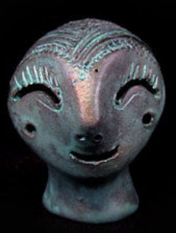 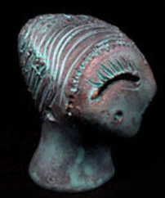 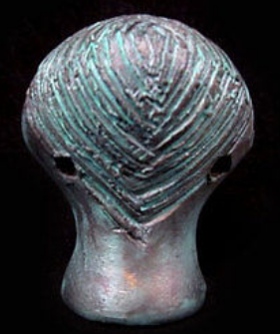

**NEOLITHIC CERAMIC IDOL –VI  MILLENNIA B.C, REPLICA!!!**

**You are bidding for Replica of a Neolithic Idol made of clay and hand decorated - VI Millennia B.C. – Ceramic. It is hollow inside and holed on both sides in case to be worn as a pendant.**

**The Original was found in the ruins of a Neolithic settlement in the region of STARA ZAGORA , BULGARIA). And at the moment the Original is for a display in the Archaeological Museum in Stara Zagora.**

**The Replica is made of a ceramic material and painted with special varnish and paints.**

**Amazing style and design. Its a perfect artefact for your home interior or for a nice gift to your friends!!!**

**Size:45/30 mm.                Weight:16g.**